Supply chain data analysis:
Company m ek chain ki trah kaam hota h from the production of the product to its delievery, first of all, the company uses raw material and then converts it. This raw material actually moves to the company which is actually a processing house. After the production of the final product, the product moves to the warehouse/ inventory. After inventory, there comes the shipment stage, where we deliver product to customers via courier service and then we calculate the total revenue generated. So, this whole work from raw material to revenue generation, the whole chain is called supply chain.
Now comes to the difference between supply chain and logistics. Supply chain is actually the whole process which involves:
- Raw materials
- Production
- Transfer to inventory
- Shipment (inventory to customer)
- Determining the revenue
Logistics is actually a part of supply chain process which involves transfer of goods from company to customer. We also determine how many products are entrying the inventory and how many going out. Determining the production of more products actually depends on supply chain management instead of logistics, yani mazeed y baat dekhni k mazeed kitni products bnani h y logistics k under nhi ayta, y supply chain k under ata h

USE OF ‘NEW PARAMETER’ FUNCTION OF POWER QUERY EDITOR:
When we load our data to PowerQE editor, all the files are present in a specific file location. For example, each file in the dataset has a specific location. When we transfer or when we send this project to someone else, the files' location cause error because the dataset files present in our computer has a specific location, and this location is different from the dataset files location that is present in their computer. As a result, he cannot use the project; it will generate an error because PowerQE editor is trying to look at the location that is present in the project to get dataset files, and when there is no file present in that location, it cause error because the location of files in the project’s receiver's computer has a different location, if we don’t use this feature, then receiver ko hr hr data file k liye source m ja kr file ka new path dena pry ga, agr hm y feature use kr lety hn to usy just ek hi jga dena pry ga new file location ko
For this reason, we will go to the Home tab of Power Query Editor, click Manage parameters, and then we will click on New parameters under Manage parameters drop-down. This will create a new window in which we will write a parameter name (it can be any name). In this case We write name “folder path” and also put the same name “folder path” under the current value, and then we will get OK.
In the left side of PowerQri editor where the names of all dataset files are shown, there is another folder, or, as it is shown as file names, a file named 'folder path' will be shown. Now, in the dataset where all files' names are present, jo k sab s upper show hoti h, we will copy the path and go inside this 'folder path' file, which is shown in the query section at last. We will copy that path in the current value with the \ at the end of the folder path
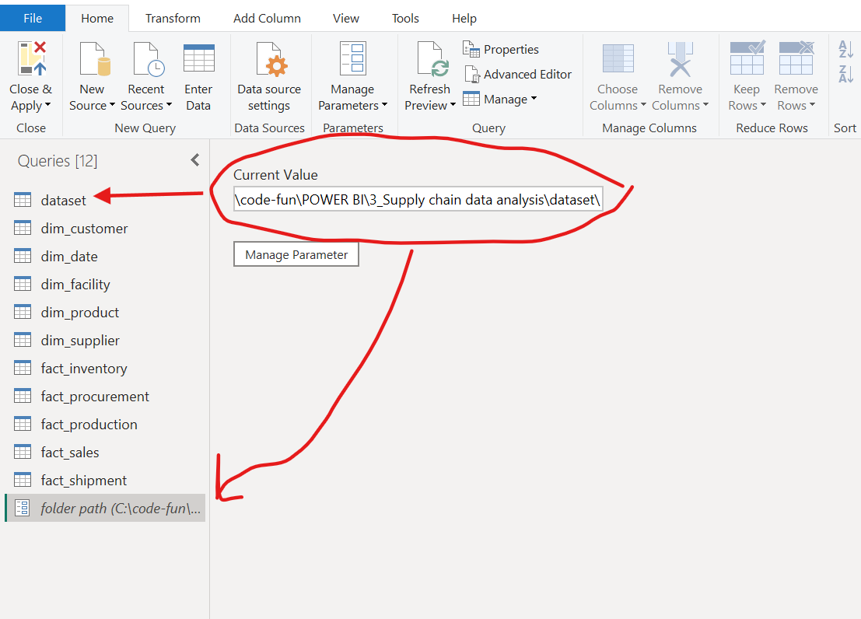
Now we will go to each file dim_customer, dim_date etc etc and applied steps m navigation m ja kr upper jahn folder path p[ura mention h commas k andr, us ko hta kr just folder path likh den gy, or esa hm hr hr data file k saath kryn gy,
Now if we change the locationof dataset in our computer and refresh the power query editor, we will get error like that:
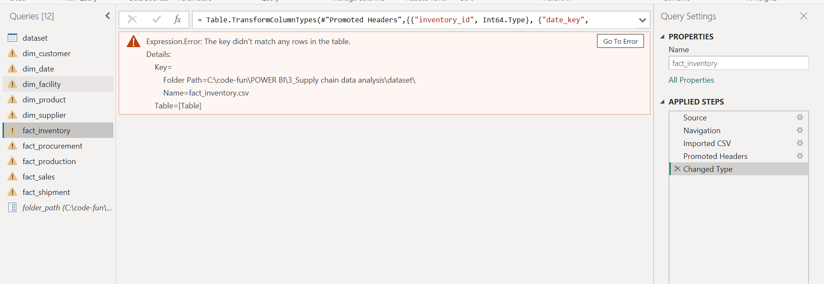
Because file location is changed , esa error hi receiver/client ko bhi ay ga, is liye hm just changed location ka path folder path m (jo k last m mention h jo hm new parameter k zrye bnai thi) den gy and refresh krny s saary ki saary errors khatam ho jayn gy,,, if we have not used new parameter function, we have to change the file path across each data file inside source

Procurement table shows purchasing transactions, including what was bought, from which supplier, in what quantity, at what cost, and when it was delivered.
Measures we have generated:
Net profit
Net profit margin
Total revenue
Toyal quantity sold

